1.

SQL> SELECT ACC.CUSTOMER_ID, ACC.ACCOUNT_TYPE, ACC.ACCOUNT_NO, BANK.BANK_NAME

2 FROM BANK_INFO BANK

3 INNER JOIN ACCOUNT_INFO ACC ON BANK.IFSC_CODE=ACC.IFSC_CODE;

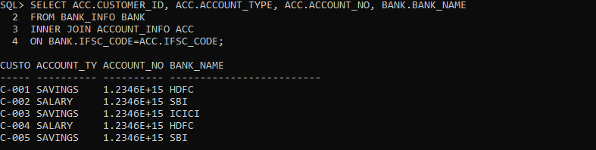

2.

1 SELECT ACC.CUSTOMER_ID, ACC.ACCOUNT_TYPE, ACC.ACCOUNT_NO

2 FROM ACCOUNT_INFO ACC

3 INNER JOIN BANK_INFO BANK ON ACC.IFSC_CODE=BANK.IFSC_CODE

4 WHERE ACC.REGISTRATION_DATE BETWEEN '13-jan-2012' AND '03-apr-2012' AND BANK.BANK_NAME='HDFC'

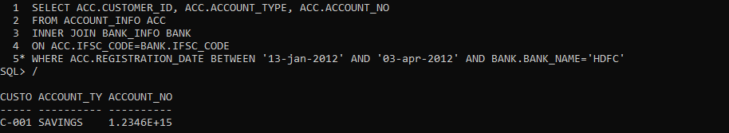

3.

SELECT CUST.CUSTOMER_ID, CUST.CUSTOMER_NAME, ACCOUNT.ACCOUNT_NO, ACCOUNT.ACCOUNT_TYPE, BAN.BANK_NAME

2 FROM BANK_INFO BAN

3 INNER JOIN ACCOUNT_INFO ACCOUNT ON BAN.IFSC_CODE=ACCOUNT.IFSC_CODE

4 INNER JOIN CUSTOMER_PERSONAL_INFO CUST ON CUST.CUSTOMER_ID=ACCOUNT.CUSTOMER_ID

5 WHERE ACCOUNT.ACCOUNT_NO IS NOT NULL;

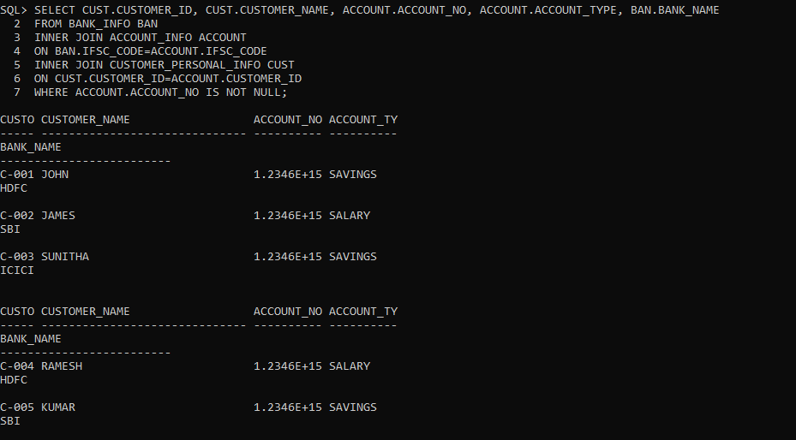

4.

SELECT CUSTOMER_ID, CUSTOMER_NAME, GENDER, MARITAL_STATUS, CUSTOMER_NAME || '_' || GENDER || '_' || MARITAL_STATUS AS UNIQUE_REF_STRING FROM CUSTOMER_PERSONAL_INFO;

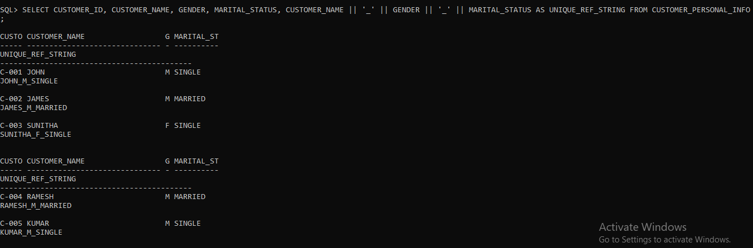

5.

SELECT ACCOUNT_NO, CUSTOMER_ID, REGISTRATION_DATE, INITIAL_DEPOSIT

2 FROM ACCOUNT_INFO

3 WHERE INITIAL_DEPOSIT BETWEEN 15000 AND 25000;

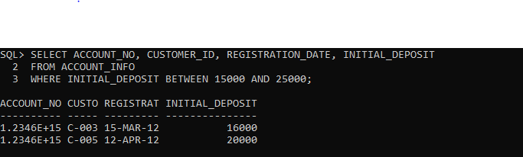

6.

SELECT CUSTOMER_ID, CUSTOMER_NAME, DATE_OF_BIRTH, GUARDIAN_NAME

2 FROM CUSTOMER_PERSONAL_INFO

3 WHERE CUSTOMER_NAME LIKE 'J%';

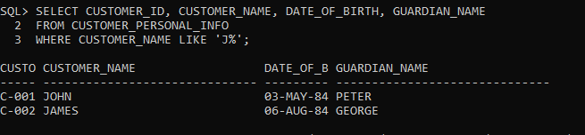

7.

SELECT CUSTOMER_ID, ACCOUNT_NO, SUBSTR(CUSTOMER_ID, -3,3) || SUBSTR(ACCOUNT_NO, -4,4) AS PASSCODECODE

2 FROM ACCOUNT_INFO;

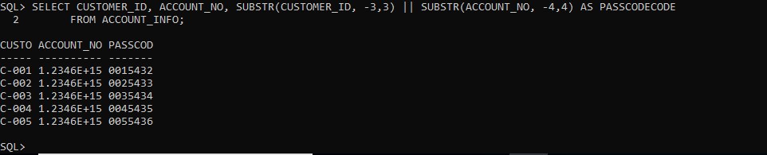

8.

SELECT CUSTOMER_ID, CUSTOMER_NAME, DATE_OF_BIRTH, MARITAL_STATUS, GENDER, GUARDIAN_NAME, CONTACT_NO, MAIL_ID

2 FROM CUSTOMER_PERSONAL_INFO

3 WHERE GENDER='M' AND MARITAL_STATUS='MARRIED';

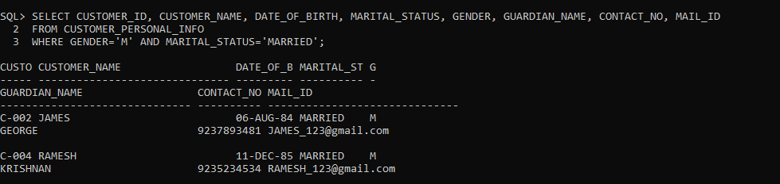

9.

SELECT CUST.CUSTOMER_ID, CUST.CUSTOMER_NAME, CUST.GUARDIAN_NAME, REF.REFERENCE_ACC_NAME AS FRIEND

2 FROM CUSTOMER_PERSONAL_INFO CUST

3 INNER JOIN CUSTOMER_REFERENCE_INFO REF

4 ON CUST.CUSTOMER_ID=REF.CUSTOMER_ID;

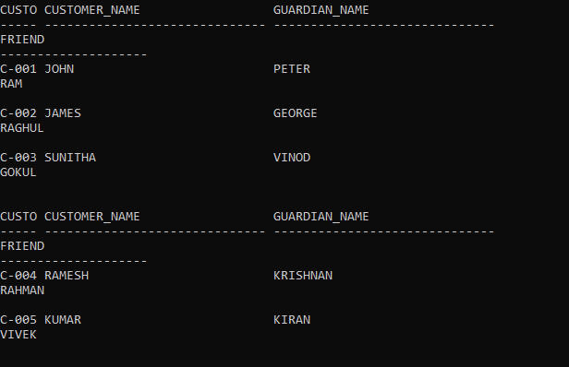

10.

SELECT SELECT CUSTOMER_ID, ACCOUNT_NO, CONCAT('$',ROUND(INTEREST,0)) AS INTEREST_AMT

2 FROM ACCOUNT_INFO

3* order by interest_amt

SQL> /

CUSTO ACCOUNT_NO INTEREST_AMT

----- ---------- -----------------------------------------

C-003 1.2346E+15 $4

C-001 1.2346E+15 $5

C-002 1.2346E+15 $6

C-004 1.2346E+15 $7

C-005 1.2346E+15 $8

11.

1 SELECT PER.CUSTOMER_ID, PER.CUSTOMER_NAME, ACCO.ACCOUNT_NO, ACCO.ACCOUNT_TYPE, ACCO.ACTIVATION_DATE, BANK.BANK_NAME

2 FROM CUSTOMER_PERSONAL_INFO PER

3 INNER JOIN ACCOUNT_INFO ACCO ON PER.CUSTOMER_ID=ACCO.CUSTOMER_ID

4 INNER JOIN BANK_INFO BANK ON BANK.IFSC_CODE=ACCO.IFSC_CODE

5* WHERE ACCO.ACTIVATION_DATE='10-apr-2012'

6 /

CUSTO CUSTOMER_NAME ACCOUNT_NO ACCOUNT_TY ACTIVATIO

----- ------------------------------ ---------- ---------- ---------

BANK_NAME

-------------------------

C-004 RAMESH 1.2346E+15 SALARY 10-APR-12

HDFC

12.

SQL> SELECT ACC.ACCOUNT_NO, PER.CUSTOMER_ID, PER.CUSTOMER_NAME, BA.BANK_NAME, BA.BRANCH_NAME, BA.IFSC_CODE, PER.CITIZENSHIP, ACC.INTEREST, ACC.INITIAL_DEPOSIT

2 FROM CUSTOMER_PERSONAL_INFO PER

3 INNER JOIN ACCOUNT_INFO ACC ON PER.CUSTOMER_ID=ACC.CUSTOMER_ID

4 INNER JOIN BANK_INFO BA ON BA.IFSC_CODE=ACC.IFSC_CODE;

ACCOUNT_NO CUSTO CUSTOMER_NAME BANK_NAME

---------- ----- ------------------------------ -------------------------

BRANCH_NAME IFSC_CODE CITIZENSHI INTEREST INITIAL_DEPOSIT

------------------------- --------------- ---------- ---------- ---------------

1.2346E+15 C-004 RAMESH HDFC

VALASARAVAKKAM HDVL0012 INDIAN 7 0

1.2346E+15 C-001 JOHN HDFC

VALASARAVAKKAM HDVL0012 INDIAN 5 10000

1.2346E+15 C-002 JAMES SBI

TNAGAR SBITN0123 INDIAN 6 0

ACCOUNT_NO CUSTO CUSTOMER_NAME BANK_NAME

---------- ----- ------------------------------ -------------------------

BRANCH_NAME IFSC_CODE CITIZENSHI INTEREST INITIAL_DEPOSIT

------------------------- --------------- ---------- ---------- ---------------

1.2346E+15 C-003 SUNITHA ICICI

TNAGAR ICITN0232 INDIAN 4 16000

1.2346E+15 C-005 KUMAR SBI

SAIDAPET SBISD0113 INDIAN 8 20000

13.

SELECT INFO.CUSTOMER_ID, INFO.CUSTOMER_NAME, INFO.DATE_OF_BIRTH, INFO.GUARDIAN_NAME, INFO.MAIL_ID, REFRENCE.REFERENCE_ACC_NAME

2 FROM CUSTOMER_PERSONAL_INFO INFO

3 INNER JOIN CUSTOMER_REFERENCE_INFO REFRENCE ON INFO.CUSTOMER_ID=REFRENCE.CUSTOMER_ID

4 WHERE INFO.IDENTIFICATION_DOC_TYPE='PASSPORT';

CUSTO CUSTOMER_NAME DATE_OF_B GUARDIAN_NAME

----- ------------------------------ --------- ------------------------------

MAIL_ID REFERENCE_ACC_NAME

------------------------------ --------------------

C-001 JOHN 03-MAY-84 PETER

JOHN_123@gmail.com RAM

C-002 JAMES 06-AUG-84 GEORGE

JAMES_123@gmail.com RAGHUL

C-004 RAMESH 11-DEC-85 KRISHNAN

RAMESH_123@gmail.com RAHMAN

CUSTO CUSTOMER_NAME DATE_OF_B GUARDIAN_NAME

----- ------------------------------ --------- ------------------------------

MAIL_ID REFERENCE_ACC_NAME

------------------------------ --------------------

C-005 KUMAR 26-APR-83 KIRAN

KUMAR_123@gmail.com VIVEK

14.

SELECT PUS.CUSTOMER_ID, PUS.CUSTOMER_NAME, CUS.ACCOUNT_NO, CUS.ACCOUNT_TYPE, CUS.INITIAL_DEPOSIT, CUS.INTEREST FROM CUSTOMER_PERSONAL_INFO PUS, ACCOUNT_INFO CUS WHERE PUS.CUSTOMER_ID=CUS.CUSTOMER_ID AND INITIAL_DEPOSIT=(SELECT MAX(INITIAL_DEPOSIT) FROM ACCOUNT_INFO);

CUSTO CUSTOMER_NAME ACCOUNT_NO ACCOUNT_TY INITIAL_DEPOSIT

----- ------------------------------ ---------- ---------- ---------------

INTEREST

----------

C-005 KUMAR 1.2346E+15 SAVINGS 20000

8

15.

SELECT A.CUSTOMER_ID, A.CUSTOMER_NAME, B.ACCOUNT_NO, B.ACCOUNT_TYPE,B.INTEREST, BANK_NAME, INITIAL_DEPOSIT FROM CUSTOMER_PERSONAL_INFO A, ACCOUNT_INFO B, BANK_INFO C WHERE A.CUSTOMER_ID=B.CUSTOMER_ID AND B.IFSC_CODE=C.IFSC_CODE AND INTEREST IN (SELECT MAX(INTEREST) FROM ACCOUNT_INFO);

CUSTO CUSTOMER_NAME ACCOUNT_NO ACCOUNT_TY INTEREST

----- ------------------------------ ---------- ---------- ----------

BANK_NAME INITIAL_DEPOSIT

------------------------- ---------------

C-005 KUMAR 1.2346E+15 SAVINGS 8

SBI 20000

16.

SELECT PERSO.CUSTOMER_ID, PERSO.CUSTOMER_NAME, ACC.ACCOUNT_NO, BANK.BANK_NAME, BANK.BRANCH_NAME, PERSO.CONTACT_NO, PERSO.MAIL_ID

2 FROM CUSTOMER_PERSONAL_INFO PERSO

3 INNER JOIN ACCOUNT_INFO ACC ON PERSO.CUSTOMER_ID=ACC.CUSTOMER_ID

4 INNER JOIN BANK_INFO BANK ON BANK.IFSC_CODE=ACC.IFSC_CODE

5 WHERE PERSO.ADDRESS LIKE '%BANGALORE';

CUSTO CUSTOMER_NAME ACCOUNT_NO BANK_NAME

----- ------------------------------ ---------- -------------------------

BRANCH_NAME CONTACT_NO MAIL_ID

------------------------- ---------- ------------------------------

C-001 JOHN 1.2346E+15 HDFC

VALASARAVAKKAM 9734526719 JOHN_123@gmail.com

C-002 JAMES 1.2346E+15 SBI

TNAGAR 9237893481 JAMES_123@gmail.com

C-005 KUMAR 1.2346E+15 SBI

SAIDAPET 9242342312 KUMAR_123@gmail.com

17.

SELECT PER.CUSTOMER_ID, BA.BANK_NAME, BA.BRANCH_NAME, BA.IFSC_CODE, ACC.REGISTRATION_DATE, ACC.ACTIVATION_DATE

2 FROM CUSTOMER_PERSONAL_INFO PER

3 INNER JOIN ACCOUNT_INFO ACC ON PER.CUSTOMER_ID=ACC.CUSTOMER_ID

4 INNER JOIN BANK_INFO BA ON BA.IFSC_CODE=ACC.IFSC_CODE

5* WHERE TO_CHAR(ACTIVATION_DATE,'mon')='mar'

SQL> /

CUSTO BANK_NAME BRANCH_NAME IFSC_CODE

----- ------------------------- ------------------------- ---------------

REGISTRAT ACTIVATIO

--------- ---------

C-002 SBI TNAGAR SBITN0123

12-MAR-12 17-MAR-12

C-003 ICICI TNAGAR ICITN0232

15-MAR-12 20-MAR-12

18.

SQL> SELECT ((INTEREST/100)*INITIAL_DEPOSIT) AS INTEREST_AMT, PERS.CUSTOMER_ID, PERS.CUSTOMER_NAME, ACC.ACCOUNT_NO, ACC.ACCOUNT_TYPE, ACC.INTEREST, ACC.INITIAL_DEPOSIT

2 FROM CUSTOMER_PERSONAL_INFO PERS

3 INNER JOIN ACCOUNT_INFO ACC ON PERS.CUSTOMER_ID=ACC.CUSTOMER_ID;

INTEREST_AMT CUSTO CUSTOMER_NAME ACCOUNT_NO ACCOUNT_TY

------------ ----- ------------------------------ ---------- ----------

INTEREST INITIAL_DEPOSIT

---------- ---------------

500 C-001 JOHN 1.2346E+15 SAVINGS

5 10000

0 C-002 JAMES 1.2346E+15 SALARY

6 0

640 C-003 SUNITHA 1.2346E+15 SAVINGS

4 16000

INTEREST_AMT CUSTO CUSTOMER_NAME ACCOUNT_NO ACCOUNT_TY

------------ ----- ------------------------------ ---------- ----------

INTEREST INITIAL_DEPOSIT

---------- ---------------

0 C-004 RAMESH 1.2346E+15 SALARY

7 0

1600 C-005 KUMAR 1.2346E+15 SAVINGS

8 20000

19.

SELECT PERSONAL.CUSTOMER_ID, PERSONAL.CUSTOMER_NAME, PERSONAL.DATE_OF_BIRTH, PERSONAL.GUARDIAN_NAME, PERSONAL.CONTACT_NO, PERSONAL.MAIL_ID, REFERENCE.REFERENCE_ACC_NAME

2 FROM CUSTOMER_PERSONAL_INFO PERSONAL

3 INNER JOIN CUSTOMER_REFERENCE_INFO REFERENCE ON PERSONAL.CUSTOMER_ID=REFERENCE.CUSTOMER_ID

4 WHERE REFERENCE.REFERENCE_ACC_NAME='RAGHUL';

CUSTO CUSTOMER_NAME DATE_OF_B GUARDIAN_NAME

----- ------------------------------ --------- ------------------------------

CONTACT_NO MAIL_ID REFERENCE_ACC_NAME

---------- ------------------------------ --------------------

C-002 JAMES 06-AUG-84 GEORGE

9237893481 JAMES_123@gmail.com RAGHUL

20.

SELECT CUSTOMER_ID, CUSTOMER_NAME, '+91-' || SUBSTR(CONTACT_NO,1,3) || '-' || SUBSTR(CONTACT_NO,4,3) || '-' ||SUBSTR(CONTACT_NO,-4) AS CONTACT_ISD FROM CUSTOMER_PERSONAL_INFO ORDER BY CUSTOMER_ID DESC;

CUSTO CUSTOMER_NAME CONTACT_ISD

----- ------------------------------ ----------------

C-005 KUMAR +91-924-234-2312

C-004 RAMESH +91-923-523-4534

C-003 SUNITHA +91-943-897-8389

C-002 JAMES +91-923-789-3481

C-001 JOHN +91-973-452-6719

21.

SELECT ACCO.ACCOUNT_NO, ACCO.ACCOUNT_TYPE, PERSON.CUSTOMER_ID, PERSON.CUSTOMER_NAME, PERSON.DATE_OF_BIRTH, PERSON.GUARDIAN_NAME, PERSON.CONTACT_NO, PERSON.MAIL_ID, PERSON.GENDER,

2 REL.REFERENCE_ACC_NAME, REL.REFERENCE_ACC_NO, ACCO.REGISTRATION_DATE, ACCO.ACTIVATION_DATE, (ACTIVATION_DATE- REGISTRATION_DATE) AS NoofdaysforActivation,

3 BANK.BANK_NAME, BANK.BRANCH_NAME, ACCO.INITIAL_DEPOSIT

4 FROM CUSTOMER_PERSONAL_INFO PERSON

5 INNER JOIN ACCOUNT_INFO ACCO

6 ON PERSON.CUSTOMER_ID=ACCO.CUSTOMER_ID

7 INNER JOIN BANK_INFO BANK

8 ON BANK.IFSC_CODE=ACCO.IFSC_CODE

9 INNER JOIN CUSTOMER_REFERENCE_INFO REL

10 ON REL.CUSTOMER_ID=PERSON.CUSTOMER_ID ;

ACCOUNT_NO ACCOUNT_TY CUSTO CUSTOMER_NAME DATE_OF_B

---------- ---------- ----- ------------------------------ ---------

GUARDIAN_NAME CONTACT_NO MAIL_ID G

------------------------------ ---------- ------------------------------ -

REFERENCE_ACC_NAME REFERENCE_ACC_NO REGISTRAT ACTIVATIO NOOFDAYSFORACTIVATION

-------------------- ---------------- --------- --------- ---------------------

BANK_NAME BRANCH_NAME INITIAL_DEPOSIT

------------------------- ------------------------- ---------------

1.2346E+15 SAVINGS C-001 JOHN 03-MAY-84

PETER 9734526719 JOHN_123@gmail.com M

RAM 9.8765E+14 23-FEB-12 28-FEB-12 5

HDFC VALASARAVAKKAM 10000

ACCOUNT_NO ACCOUNT_TY CUSTO CUSTOMER_NAME DATE_OF_B

---------- ---------- ----- ------------------------------ ---------

GUARDIAN_NAME CONTACT_NO MAIL_ID G

------------------------------ ---------- ------------------------------ -

REFERENCE_ACC_NAME REFERENCE_ACC_NO REGISTRAT ACTIVATIO NOOFDAYSFORACTIVATION

-------------------- ---------------- --------- --------- ---------------------

BANK_NAME BRANCH_NAME INITIAL_DEPOSIT

------------------------- ------------------------- ---------------

1.2346E+15 SALARY C-002 JAMES 06-AUG-84

GEORGE 9237893481 JAMES_123@gmail.com M

RAGHUL 9.8765E+14 12-MAR-12 17-MAR-12 5

SBI TNAGAR 0

ACCOUNT_NO ACCOUNT_TY CUSTO CUSTOMER_NAME DATE_OF_B

---------- ---------- ----- ------------------------------ ---------

GUARDIAN_NAME CONTACT_NO MAIL_ID G

------------------------------ ---------- ------------------------------ -

REFERENCE_ACC_NAME REFERENCE_ACC_NO REGISTRAT ACTIVATIO NOOFDAYSFORACTIVATION

-------------------- ---------------- --------- --------- ---------------------

BANK_NAME BRANCH_NAME INITIAL_DEPOSIT

------------------------- ------------------------- ---------------

1.2346E+15 SAVINGS C-003 SUNITHA 06-NOV-84

VINOD 9438978389 SUNITHA_123@gmail.com F

GOKUL 9.8765E+14 15-MAR-12 20-MAR-12 5

ICICI TNAGAR 16000

ACCOUNT_NO ACCOUNT_TY CUSTO CUSTOMER_NAME DATE_OF_B

---------- ---------- ----- ------------------------------ ---------

GUARDIAN_NAME CONTACT_NO MAIL_ID G

------------------------------ ---------- ------------------------------ -

REFERENCE_ACC_NAME REFERENCE_ACC_NO REGISTRAT ACTIVATIO NOOFDAYSFORACTIVATION

-------------------- ---------------- --------- --------- ---------------------

BANK_NAME BRANCH_NAME INITIAL_DEPOSIT

------------------------- ------------------------- ---------------

1.2346E+15 SALARY C-004 RAMESH 11-DEC-85

KRISHNAN 9235234534 RAMESH_123@gmail.com M

RAHMAN 9.8765E+14 05-APR-12 10-APR-12 5

HDFC VALASARAVAKKAM 0

ACCOUNT_NO ACCOUNT_TY CUSTO CUSTOMER_NAME DATE_OF_B

---------- ---------- ----- ------------------------------ ---------

GUARDIAN_NAME CONTACT_NO MAIL_ID G

------------------------------ ---------- ------------------------------ -

REFERENCE_ACC_NAME REFERENCE_ACC_NO REGISTRAT ACTIVATIO NOOFDAYSFORACTIVATION

-------------------- ---------------- --------- --------- ---------------------

BANK_NAME BRANCH_NAME INITIAL_DEPOSIT

------------------------- ------------------------- ---------------

1.2346E+15 SAVINGS C-005 KUMAR 26-APR-83

KIRAN 9242342312 KUMAR_123@gmail.com M

VIVEK 9.8765E+14 12-APR-12 17-APR-12 5

SBI SAIDAPET 20000

22. SELECT PERS.CUSTOMER_ID, PERS.CUSTOMER_NAME, PERS.GUARDIAN_NAME, PERS.IDENTIFICATION_DOC_TYPE, REF.REFERENCE_ACC_NAME, ACC.ACCOUNT_TYPE, BANK.IFSC_CODE, BANK.BANK_NAME, TRUNC((INITIAL_DEPOSIT+INTEREST),0) AS CURRENT_BALANCE

2 FROM CUSTOMER_PERSONAL_INFO PERS

3 INNER JOIN ACCOUNT_INFO ACC ON PERS.CUSTOMER_ID=ACC.CUSTOMER_ID

4 INNER JOIN BANK_INFO BANK ON BANK.IFSC_CODE=ACC.IFSC_CODE

5 INNER JOIN CUSTOMER_REFERENCE_INFO REF ON REF.CUSTOMER_ID=PERS.CUSTOMER_ID

6 WHERE ACCOUNT_TYPE='SAVINGS'

7 ;

CUSTO CUSTOMER_NAME GUARDIAN_NAME

----- ------------------------------ ------------------------------

IDENTIFICATION_DOC_T REFERENCE_ACC_NAME ACCOUNT_TY IFSC_CODE

-------------------- -------------------- ---------- ---------------

BANK_NAME CURRENT_BALANCE

------------------------- ---------------

C-001 JOHN PETER

PASSPORT RAM SAVINGS HDVL0012

HDFC 10005

C-003 SUNITHA VINOD

VOTER-ID GOKUL SAVINGS ICITN0232

ICICI 16004

CUSTO CUSTOMER_NAME GUARDIAN_NAME

----- ------------------------------ ------------------------------

IDENTIFICATION_DOC_T REFERENCE_ACC_NAME ACCOUNT_TY IFSC_CODE

-------------------- -------------------- ---------- ---------------

BANK_NAME CURRENT_BALANCE

------------------------- ---------------

C-005 KUMAR KIRAN

PASSPORT VIVEK SAVINGS SBISD0113

SBI 20008

23.

SELECT CUSTOMER.CUSTOMER_ID, CUSTOMER.CUSTOMER_NAME, ACC.ACCOUNT_NO, ACC.ACCOUNT_TYPE, ACC.INTEREST, ACC.INITIAL_DEPOSIT,

2 CASE

3 WHEN INITIAL_DEPOSIT=20000 THEN 'high'

4 WHEN INITIAL_DEPOSIT=16000 THEN 'moderate'

5 WHEN INITIAL_DEPOSIT=10000 THEN 'average'

6 WHEN INITIAL_DEPOSIT=5000 THEN 'low'

7 WHEN INITIAL_DEPOSIT=0 THEN 'very low'

8 ELSE 'invalid' END DEPOSIT_STATUS

9 FROM CUSTOMER_PERSONAL_INFO CUSTOMER

10 INNER JOIN ACCOUNT_INFO ACC

11* ON CUSTOMER.CUSTOMER_ID=ACC.CUSTOMER_ID

SQL> /

CUSTO CUSTOMER_NAME ACCOUNT_NO ACCOUNT_TY INTEREST

----- ------------------------------ ---------- ---------- ----------

INITIAL_DEPOSIT DEPOSIT_

--------------- --------

C-001 JOHN 1.2346E+15 SAVINGS 5

10000 average

C-002 JAMES 1.2346E+15 SALARY 6

0 very low

C-003 SUNITHA 1.2346E+15 SAVINGS 4

16000 moderate

CUSTO CUSTOMER_NAME ACCOUNT_NO ACCOUNT_TY INTEREST

----- ------------------------------ ---------- ---------- ----------

INITIAL_DEPOSIT DEPOSIT_

--------------- --------

C-004 RAMESH 1.2346E+15 SALARY 7

0 very low

C-005 KUMAR 1.2346E+15 SAVINGS 8

20000 high

24.

SELECT PING.CUSTOMER_ID, PING.CUSTOMER_NAME, ACCOUNT.ACCOUNT_NO, ACCOUNT.ACCOUNT_TYPE, BAN.BANK_NAME, BAN.IFSC_CODE, ACCOUNT.INITIAL_DEPOSIT,

2 CASE

3 WHEN ACCOUNT_TYPE='SAVINGS' THEN ROUND((INTEREST+(INTEREST*10/100)),2)

4 ELSE INTEREST END NEW_INTEREST

5 FROM CUSTOMER_PERSONAL_INFO PING

6 INNER JOIN ACCOUNT_INFO ACCOUNT ON PING.CUSTOMER_ID=ACCOUNT.CUSTOMER_ID

7 INNER JOIN BANK_INFO BAN ON BAN.IFSC_CODE=ACCOUNT.IFSC_CODE

8 WHERE PING.CUSTOMER_NAME LIKE 'J%';

CUSTO CUSTOMER_NAME ACCOUNT_NO ACCOUNT_TY

----- ------------------------------ ---------- ----------

BANK_NAME IFSC_CODE INITIAL_DEPOSIT NEW_INTEREST

------------------------- --------------- --------------- ------------

C-001 JOHN 1.2346E+15 SAVINGS

HDFC HDVL0012 10000 5.5

C-002 JAMES 1.2346E+15 SALARY

SBI SBITN0123 0 6

25.

SELECT PER.CUSTOMER_ID, PER.CUSTOMER_NAME, ACCOUNT.ACCOUNT_NO, ACCOUNT.INITIAL_DEPOSIT,

2 CASE

3 WHEN INITIAL_DEPOSIT=0 THEN '0%'

4 WHEN INITIAL_DEPOSIT<=10000 THEN '3%'

5 WHEN INITIAL_DEPOSIT>10000 AND INITIAL_DEPOSIT<20000 THEN '5%'

6 WHEN INITIAL_DEPOSIT>=20000 AND INITIAL_DEPOSIT<=30000 THEN '7%'

7 WHEN INITIAL_DEPOSIT>30000 THEN '10%' END taxPERCENTAGE

8 FROM CUSTOMER_PERSONAL_INFO PER INNER JOIN ACCOUNT_INFO ACCOUNT ON PER.CUSTOMER_ID=ACCOUNT.CUSTOMER_ID;

CUSTO CUSTOMER_NAME ACCOUNT_NO INITIAL_DEPOSIT TAX

----- ------------------------------ ---------- --------------- ---

C-001 JOHN 1.2346E+15 10000 3%

C-002 JAMES 1.2346E+15 0 0%

C-003 SUNITHA 1.2346E+15 16000 5%

C-004 RAMESH 1.2346E+15 0 0%

C-005 KUMAR 1.2346E+15 20000 7%